10-05-2022

BIG DATA

SOHAN M 1NT19IS155

MAP REDUCE SUM

var map=function() {emit(this.name,this.marks);};
> var reduce=function(name,marks) {return Array.sum(marks);};
> db.sohan.mapReduce(map,reduce, {out:"marks"});
{ "result" : "marks", "ok" : 1 }

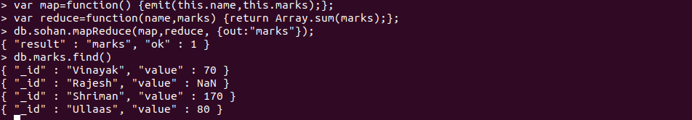

var map=function() {emit(this.dept,this.marks);};
> var reduce=function(dept,marks) {return Array.sum(marks);};
> db.sohan.mapReduce(map,reduce, {out:"marks"});
{ "result" : "marks", "ok" : 1 }

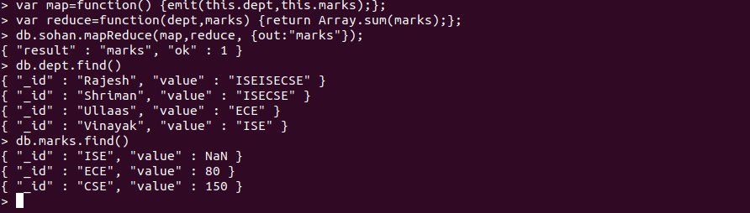

MAP REDUCE AVERAGE

> var map=function() {emit(this.dept,this.marks);};
> var reduce=function(dept,marks) {return Array.avg(marks);};
> db.sohan.mapReduce(map,reduce, {out:"marks"});
{ "result" : "marks", "ok" : 1 }
> db.marks.find()

